
Classroom Session: Extract the Value of sys_id from Create Incident and Save as Global Variable
Learning Objective:
The objective of this session is to learn how to extract the sys_id from the response of a create incident request in ServiceNow and save it as a global variable in Postman.
Expected Completion Time:
- Best Case: 20 minutes
- Average Case: 30 minutes
Session Details:

ServiceNow API Credentials:
- Obtain Your ServiceNow Instance Credentials:
  - Instance URL
  - Username
  - Password

Extracting sys_id from Create Incident Response:
Step 1: Create a new Blank Collection
- Create New Collection .
Step 2: Create a New Request
- Click on "New" and select "HTTP Request".
- Name your request appropriately, e.g., "Create Incident".
Step 3: Set Up the Request URL
- Set the request type to POST.
- Enter the ServiceNow API endpoint for creating an incident:
POST https://<your_instance>.service-now.com/api/now/table/incident
- Replace <your_instance> with your ServiceNow instance name.
Step 4: Authentication
- Go to the "Authorization" tab.
- Select "Basic Auth".
- Enter your ServiceNow Username and Password.
Step 5: Check the Headers
- Navigate to the "Headers" tab.
- Check following header:
  - Key: Content-Type Value: application/json
Step 6: Body
- Switch to the "Body" tab.
- Select raw and choose JSON from the drop-down menu.
- Enter the JSON payload for creating an incident. Example:
{
"short_description": "Test incident creation",
"description": "Software
}
Step 7: Send the Request
- Click "Send".
- Observe the response in the lower pane Body. Ensure it contains the details of the newly created incident, including the sys_id.
Step 8: Save the Response as a Variable
- Go to the "Scripts" tab and add the following script to save the response as a variable:
var resp = pm.response.json();
Step 9: Traverse Through the Response to Find sys_id Path
- Use JSONPath Finder to locate the path of sys_id in the response. For example:
x.result.sys_id
Step 10: Extract sys_id and Save as Local Variable
- Extract the sys_id from the response and save it as a local variable:
var sysid = resp.result.sys_id;
Step 11: Save the sys_id as Global Variable
- Create global variable by clicking Environments click Globals the create a global variable named systemid
- Save the value of sys_id as a global variable in Postman:

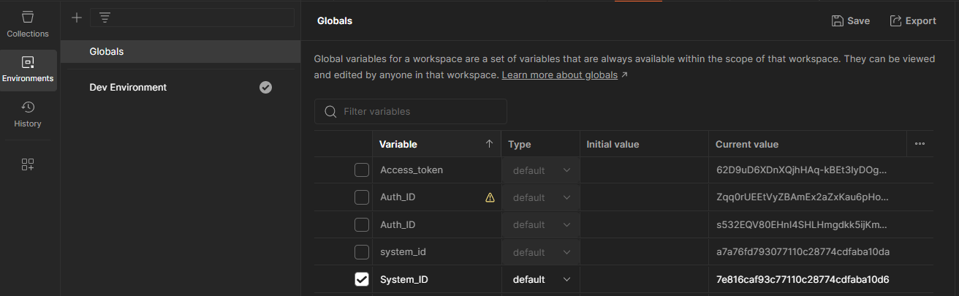
pm.globals.set("systemid", sysid);
Step 12: Send the Request and Validate
- Click "Send" again to execute the request and ensure the sys_id is saved correctly as a global variable.
- You can verify the sys_id in the console by printing using this code
console.log(sys_id)

Expected Outcome:
Upon completion, you should be able to:
- Create an incident in ServiceNow via API.
- Extract the sys_id from the response of the create incident request.
- Save the extracted sys_id as a global variable in Postman for use in subsequent requests.

